VOYAGE PROJECT
project No. 561656-EPP-1-2015-1-IT-EPPKA2-CBHE-JP - ERASMUS+ CBHE
“Opportunities for the young and graduates employability in Vietnam”

DISSEMINATION EVENT AND PROJECT MEETING
WP.3 Prototype model trials
WP.5 Develop monitoring tools for demand supply matching and employability
Sustainability (WP.7) and Management Meeting (WP.8)

9-13 April 2018, University of Padua, Italy
Aula Canova, Palazzo Storione, Riviera Tito Livio 6

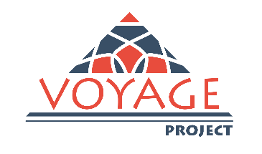

Meeting Programme

Voyage Project Consortium
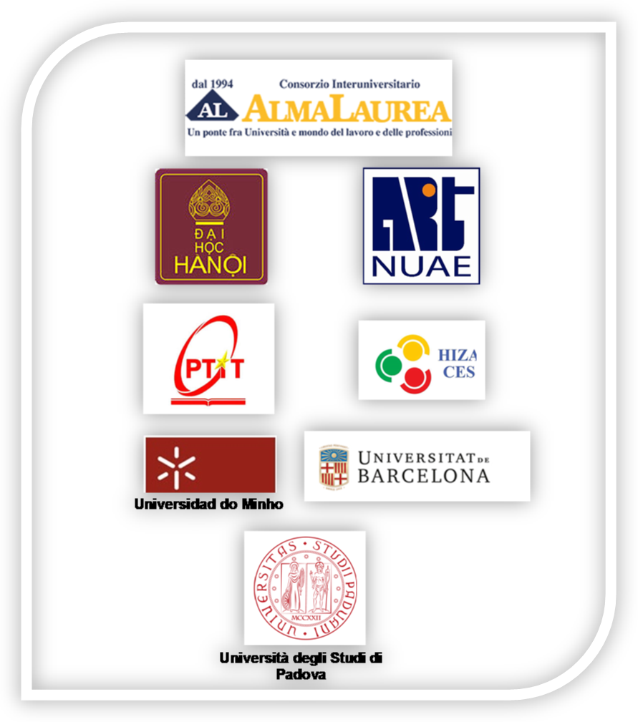
Associated partners:
General Council of Catalan Chambers of Commerce, Spain
Industrial Association of Minho (AIMinho - Associação Empresarial), Portugal
Braga Chamber of Commerce, Portugal
Unioncamere Emilia Romagna-UCER, Italy

Meeting Day 1: Monday, April 9, 2018
9.30 Registration of participants
10.00 Welcome address
Andrea Berti, Research and Business Relations Area Manager, University of Padova
Nguyen Thi Thu, Deputy Head, Vietnam International Education Development (VIED),
Ministry of Education and Training, S.R. of Vietnam
Nguyen Van Trao, Rector of Rector of the Hanoi University
Vu Van San, President of the Post and Telecommunication Institute of Technology
Dao Dang Phuong, Rector of National University of Art Education
Nguyen Duc Quang, Vice-Chairman of Hanoi Industrial Export Processing Zones Authority - Center for Enterprise Support and Services (HIZA-CES)
Manuel Felipe Costa, University of Minho
Annamaria Nguyen, Unioncamere Emilia Romagna

11.00: The education system in Vietnam and the opportunities given by the Voyage Project
Nguyen Thi Thu, Deputy Head, Vietnam International Education Development (VIED),
Ministry of Education and Training, S.R. of Vietnam

11.30 Coffee break

12.00 Introduction to the meeting and Voyage Project main achievements
AlmaLaurea
12.30 New configuration of Voyage Project in Vietnam: State of Art
Nguyen Hoang Duong, HANU

13.00 Lunch

Afternoon Session

14.30 Voyage Graduates Profile Survey: state of developing of final Survey
Silvia Galeazzi-AlmaLaurea, Nguyen Minh Phuong-PTIT
15.30: Quality Assurance Analysis: Comparison between ENQA, Voyage and Vietnamese Standards
Cacilda Moura, University of Minho

Open discussion and closing of the day

Social Dinner
“L’Isola di Caprera” Restaurant
Via Marsilio da Padova, 11

Meeting Day 2: Tuesday, April 10, 2018

9.45: Meeting point in Palazzo Storione hall

10.00 – 12.00: Signature of the Memorandum of Understanding Vietnamese Universities-University of Padua and Round table (Venue: Sala da Pranzo, Palazzo Bo’)
Rosario Rizzuto, Rector of the University of Padua
Alessandro Paccagnella, Vice Rector for International Relations of the University of Padua
Nguyen Thi Thu, Deputy Head, Vietnam International Education Development
Nguyen Van Trao, Rector of Rector of the Hanoi University
Nguyen Thanh Binh, Rector of Hanoi University of Pharmacy
Vu Van San, President of the Post and Telecommunication Institute of Technology
Dao Dang Phuong, Rector of National University of Arts Education

12.00: Signature of VOYAGE Sustainability Plan Ceremony

13.00: Lunch Time

Afternoon Session

14.30 Platform Assessment with Stakeholders-WP.3.: Final Report Presentation
Nguyen Thi Phuong Thao of NUAE, Nguyen Duc Quang -HIZA

15.30: Voyage Project Quality Control-WP.8
AlmaLaurea, Voyage Consortium

16.00: Voyage Project Sustainability Report- WP.7
Ngo Phuong Dung, Dang Thi Phuong Thao -HANU, AlmaLaurea

Open discussion and closing of the day

Meeting Day 3: Wednesday, April 11, 2018

9.30 Registration of participants

10.00: Monitoring tools for demand supply matching and employability: Final Report Presentation
Gilda Rota, University of Padua

11.00: Coffee Break

11.30: Monitoring tools for demand supply matching and employability: main suggestion for the future
Nguyen Duc Quang -HIZA-CES; Ngo Phuong Dung-HANU; Ms. Nguyen Minh Phuong-PTIT; Nguyen Thi Phuong Thao-NUAE; Antonio Maria Almeida-Minho University; Marina Sole,-University of Barcelona; Enrico Dongiovanni-AlmaLaurea
Open discussion

13.00: Lunch

Afternoon Session

15.00: Dissemination event “University-Enterprise cooperation between Vietnam, Europe and Italy”
Companies representative – Vietnamese Universities - Representative of Voyage Consortium
Presentation of VOYAGE project and employability platform

17.00 Palazzo Bo’ Tour (historical site of University)

18.00 Social Aperitivo
Caffè Pedrocchi, Via VIII Febbraio, 15

Meeting Day 4: Thursday, April 12, 2018

Management meeting

10.00: Registration of participants

10.30: Voyage Project next steps and final Conference Planning
AlmaLaurea, Voyage Project Consortium

11.30: Coffee break

12.00: Management of the Project: Financial Part

AlmaLaurea
State of Art of Expenditures
Budget change approval by EU (translation, audit process)
Reporting of costs per partner

Afternoon Session

14.30: Collection of financial documentation and next expenditure

Open discussion and Closing of the Meeting

Meeting Day 5: Friday, April 13, 2018

11.00: Visit to the University of Padua

Meeting with other representatives of Padua Universities

